**Table of Contents**

|  |
| --- |
| Home Alarm System |
| CSE 379 Design Project |
| Jules Manalang julesman@buffalo.edu |

Introduction……………………………………………..1

User Interface..…………………………………………2

AMBA Interface………………………………………..?

General Purpose Input-Output…………………?

Memory Maps…………………………….…………….?

Hardware Diagram………………………….…………?

Programming Instructions…………………………?

Parts List …………………………………………………..?

Authors Notes…………………………………………..?  
**Introduction**

The following design for a functioning home alarm system using the ARM PrimeCellTM peripherals and described within this documentation. The features of this design include 20 independent sensors that will communicate with the ARM PrimeCellTM peripherals, and a simple user interface that is both easy-to-use and is functional.

Included within this documentation are descriptions on how the ARM PrimeCellTM peripherals were used for this design as well as a parts list so that this design could be built. The documentation will also go over how to program the system so that it may be used and implanted into a household.

Do you have questions or comments? Please contact:

Jules Manalang  
University at Buffalo – Computer Engineering Student  
julesman@buffalo.edu

**User Interface**

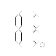RGB LED (1)

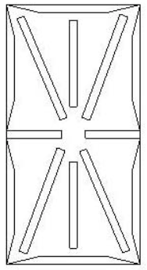

#

9

6

0

8

5

*

7

4

3

2

11

4 7-Segment Display with Decimal Point (2)   
 LED (3)

Ten 14-Segment Displays (4)

12-Button Keypad (5)

20 LEDs (6)

Magnetic Transducer (7)

* (1) RGB LED – Displays the current status of the System.
  + Green – Armed
  + Yellow – Disarmed
  + Red – Tripped
* (2) 7-segment Display with Decimal Points – 4 of these display the time maintained by the **ARM PrimeCellTM Real Time Clock** (See Page *insert page here*). This specific display actually comes as is and there is no need to actually flipping an individual display
  + The third and forth 7-segment displays are flipped upside down to emulate a colon separating the hours and minutes using the Decimal Points
* (3) LED – Displays AM or PM
  + PM when turned on
* (4) 14-Segment Display- 10 of these displays will show the user status messages and other information in regard to the system
* (5) 12-Button Keypad – This keypad will enable the user to input various commands to use the system.
* (6) LED – 20 of these LEDs will show the current status of the sensors.
  + ON – Sensor is tripped
  + OFF – Sensor is not tripped
* (7) Magnetic Transducer – Will made an audible 90db sound when a sensor is tripped triggering the alarm if the system is armed.

**The AMBA Interface  
Advanced Microcontroller Bus Architecture**

The AMBA is used to connect the ARM processor to memory and peripherals. There are three busses on the AMBA Specification.

* Advanced High-Performance Bus (AHB) – For use with high clock frequency systems. For example memory
* Advanced System Bus (ASB) – Used as an alternative to the AHB when the high performance features are not needed
* Advanced Peripheral Bus (APB) – Used for low power peripherals. UARTs, GPIOs, timers.

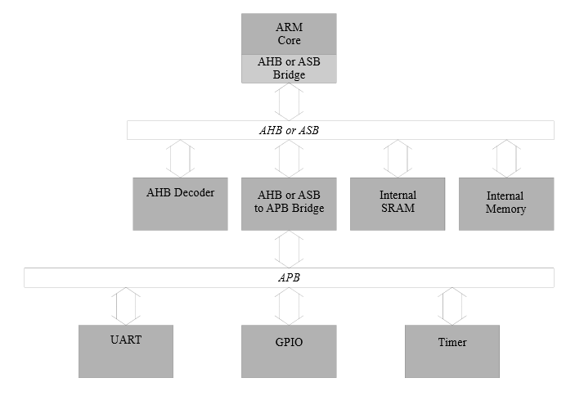  
Shown below is AMBA system that will be used for this design as well as the AMBA AHB decoder based on the memory maps on page *insert page.*

**The General Purpose Input/Output(GPIO)**

The GPIO used for this design will implement the **ARM PrimeCellTM GPIO.** This GPIO is capable of up to 8 inputs or outputs for the system. Since we have 227 inputs and outputs between the user interface and the sensors (described in this section), we will use29 GPIOs to accommodate for all of the inputs and outputs. Each GPIO takes up to 4 Kb of memory. Below is a diagram for the GPIO and how it operates. More information can be found the **ARM PrimeCellTM GPIO** technical reference manual. 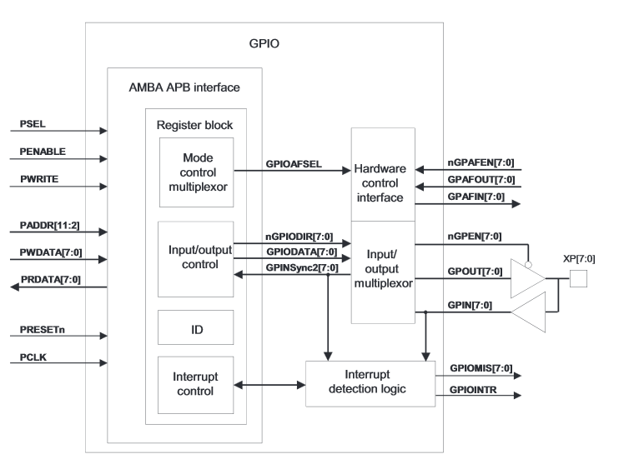

|  |  |
| --- | --- |
| **Pins (Format : GPIO.Pin)** | **Inputs and Outputs** |
| Pin 0.0 to Pin 1.5 | 14 Segment Display – 1 |
| Pin 1.6 to Pin 3.3 | 14 Segment Display – 2 |
| Pin 3.4 to Pin 5.1 | 14 Segment Display – 3 |
| Pin 5.2 to Pin 6.7 | 14 Segment Display – 4 |
| Pin 7.0 to Pin 8.5 | 14 Segment Display – 5 |
| Pin 8.6 to Pin 10.3 | 14 Segment Display – 6 |
| Pin 10.4 to Pin 12.1 | 14 Segment Display – 7 |
| Pin 12.2 to Pin 13.7 | 14 Segment Display – 8 |
| Pin 14.0 to Pin 15.5 | 14 Segment Display – 9 |
| Pin 15.6 to Pin 17.3 | 14 Segment Display – 10 |
| Pin 17.4 to Pin 21.1 | 4 7-Segment Block |
| Pin 21.2 | AM/PM LED |
| Pin 21.3 | RGB LED – Blue |
| Pin 21.4 | RGB LED – Green |
| Pin 21.5 | RGB LED – Red |
| Pin 21.6 to Pin 24.1 | Sensor LEDs |
| Pin 24.2 to Pin 26.5 | Sensors * |
| Pin 26.6 to Pin 28.1 | Keypad * |
| Pin 28.2 | Magnetic Transducer |

Below are the pins associated with the different inputs and outputs.

* - These are denoted as input values